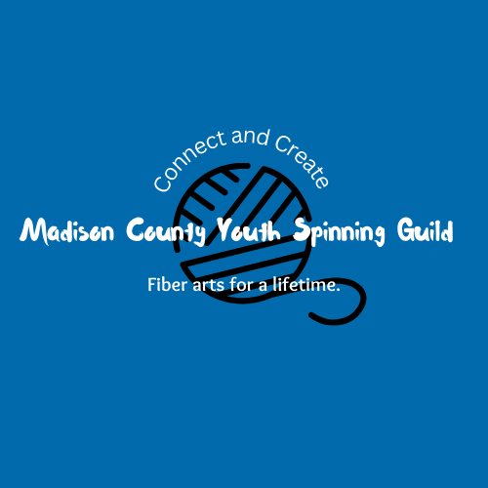

The Madison County Youth Spinning Guild is holding a holiday ornament making class for kids hosted at the Alexandria Community Center! Students will have the chance to needle felt an animal to hang on the tree, keep as a toy, or give as a gift.

**Who:** Registration is open to students that are entering grades 5 – 12.  
**Fee:** $5  
**When:** Thursday, Dec. 12 from 3-5pm

**Where:** Alexandria Community Center (315 S. Harrison St., Alexandria, IN 46001)

*Students will have a light snack and drink during camp. Please note allergies below.

** You may fill this form out at the start of the program. You may also return this registration form with fee **by Thursday, Dec. 12 at 3pm** to the ACC during business hours or leave in the drop if outside regular business hours.

Please contact Nelly DeVault at [madisoncountyyouthspinners@gmail.com](mailto:madisoncountyyouthspinners@gmail.com) or Rachel Young at 765-724-7728 or rachelyoungacc@gmail.com with any questions or concerns.***

**______________________________________________________________________________**

Student’s name________________________________ Phone Number____________________________

Age_____ Grade________ Parent Email _________________________________________

Does your child have any health problems or allergies that we should be aware of? _____________________

Fees must accompany this form unless other arrangements have been made. No refunds will be made. ACC is not responsible for accidents or injuries. In consideration of participation in the above program(s) conducted by the Alexandria Community Center & Madison County Youth Spinning Guild, I do hereby agree to hold free from any liability the ACC and its respective officers, employees, and volunteers. I do hereby for myself, my heirs, executors, and administrators waive, release, and forever discharge and all rights and claims for damages, which may hereafter, accrue to me arising out of or connected with my child’s participation in this program. I attest and verify that the participant listed above is physically fit and I have read this form and understand the expectations of this program.

Parent/Guardian (please print) _______________________________ Signature_________________________

I would like to contribute $_______ to a scholarship fund that will allow all interested area children to participate in ACC programs. page1image11546624page1image11536064page1image11544512page1image11543936page1image11535872